Departmental Use Only
Revision No: 05 | Unit: PIEP
Revision Date: 20.02.2023 | Dept.: BF Mechanical

FORMAT FOR HAZARD IDENTIFICATION
A. Work activity information
Sr. No. | Details | Remark
1) | Task being carried out, their duration and Frequency: | PCI Maintenance  2 to 10 hrs  Weekly/Fortnightly/Monthly /6 months/Yearly
2) | Location (s) where the work is carried out. | PCI
3) | Who normally/occasionally carried out the task | Engineer in charge  Maintenance fitter on the job  Mechanical contractor workmen
4) | Who else may be affected by the work (For example visitors, subcontractors, the public) | Production engineer
5) | a) Has the personnel trained for performing the task  b) Any special training required | Yes  No
6) | Is the written systems of work mandatory. If yes state the procedure no. | VL/IMS/PID2/BF3/WI/26
7) | Is the work permit required for the task | Yes
8) | Plant and machinery that may be used:  Eg : crusher, conveyor, crane, heavy earthing equipment, Truck, Hydra etc, | Yes
9) | Any electrically operated hand tools are used | Grinder, Hand Drill Machine
10) | Manufacturers or suppliers instructions for operation and maintenance plant machinery and powered hand tools are available or not: | Yes
11) | Chain block, tools and shackles such as wire rope, hydraulic jack etc are used. | Yes
12) | What materials are handled? Size, shape, surface character and weight of materials that may be handled: | Wire rope, Conveyor, Mill rollers, Gear boxes, Lubrication station.  Variable size & shape  Approx 4000 kg max
13) | Is the material is required to be moved by hand. If yes Distance and heights of the place where materials have to move by hand. | 1-2 kg by hand (tools & tackles)  10 Mt height approximately max
14) | Services used Eg: compressed air, oxygen, acetylene,  LPG gas, hydraulic oil, welding electrode for welding | Compressed air, oxygen,  LPG gas ,welding electrode for welding
15) | Physical form of substances encountered during the work (For example fume, gas, vapor, liquid, dust/powder, solid): | Solid ,dust & fumes, Coal fines, Co, N2 & LPG
16) | Content and recommendations of safety data sheets relating to substances used or encountered:  ( this is applicable in case of chemical material) | NA
17) | a) Relevant acts, regulations and standards relating to the work being done, the plant and machinery used and the materials used or encountered:  b) Is the activity is reviewed for compliance to statutory requirement | Factory Act 1948 and Goa factory rules 1985 ? SRR/16  Yes
18) | What is the data (s) required to be monitored during the activity and the frequency of monitoring. | Fine Coal silo Stock
19) | Any information available from within and outside the organization on incident, accident and ill health experience associated with the work being done, equipment and substances used: | Nil
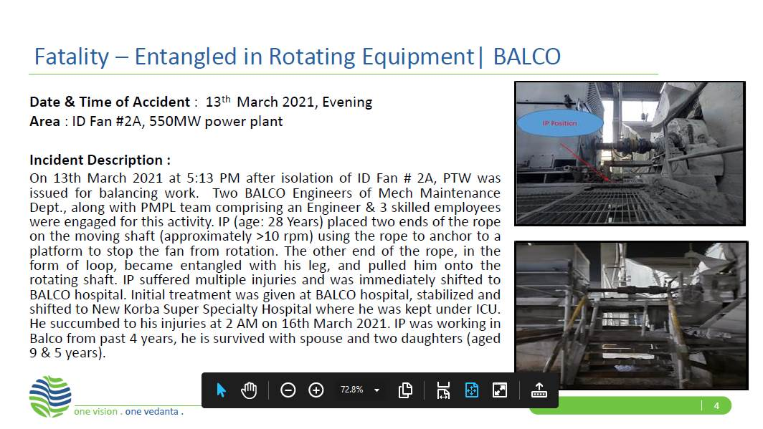

2. From the above activity information hazards are to be identified and recorded below using Appendix 'A' of SP/41
Hazards identified
Mechanical Hazard
Trapping between two objects,
Fall of material, hammer, tools, slinged items,
bolts, wedges, stock rod, pulley
Cut on hand / leg due to damaged wire rope stands during shifting / removing
Fall of equipment / person from platform
Entanglement
Impact of moving / slinged items
Human behavior- alcoholism, back pain, casual approach
Physical hazard: Pressure , Temperature, Impact of nitrogen
Chemical hazard - CO Gas poisoning, Fire
Electrical hazard - Electrical shock

Prepared By:  Site Engineer | Reviewed By:  Mech. Maint. HOD PID2
Signature: | Signature:
Review Date:03.01.2023 | Review Date:03.01.2023

